# **Guided Lab - Install the H2-in-Memory Database**

# 

# **Lab Objective:**

# In this lab, we will install the H2 database on Windows.

By the end of this lab, learners will be able to Install the H2-in-Memory Database

**Instructions:**

Following are the steps to install the H2 database on a Windows operating system.

### **Step 1: Download the H2 Setup File**

Download the latest version of the [H2](https://www.h2database.com/html/download.html) database from the following link. In this link, you will get the latest version of the H2 database in two types. One is a Windows Installer type (that is .exe file) and the second is a Platform-Independent zip file for other operating systems.

**For Windows OS,** [click here for the Windows Installer](https://h2database.com/h2-setup-2019-03-13.exe). After downloading, we get the H2 Windows installer file (.exe).

**For Mac OS:** The simplest way is to download a [Platform-Independent Zip](https://h2database.com/h2-2019-03-13.zip) file, which is suitable for all different operating systems and does not need to be installed. You only need to extract it into a folder to use it.

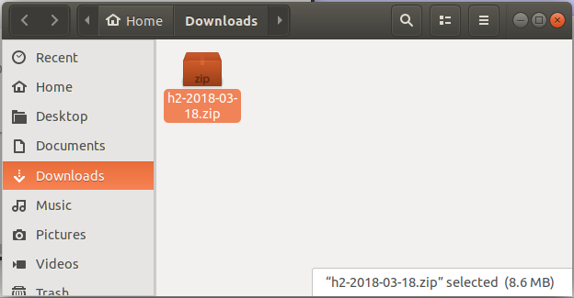

**Official Website Reference:**

<https://www.h2database.com/html/download.html>

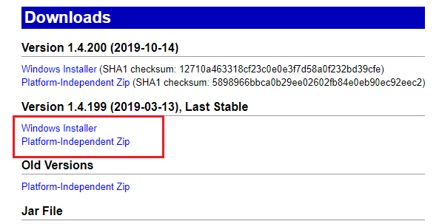

### **Step 2: Install H2 Database**

After downloading, we get the H2 Windows Installer file ( h2-setup-yyyy-mm-dd.exe) in the Downloads directory. To start the installation process of the H2 Database, double-click on the installer file.

The following screen is the first step in the installation process. Give a path to where we want to install the H2 database server, as shown in the following screenshot:

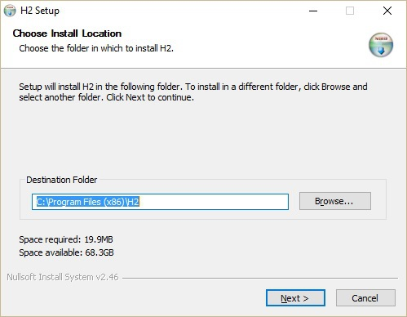

As seen in the above screenshot, by default it will state ***C:\ProgramFiles (x86)\H2*** as the destination folder. Click on the **Next** button to proceed to the next step. The following screen pops up:

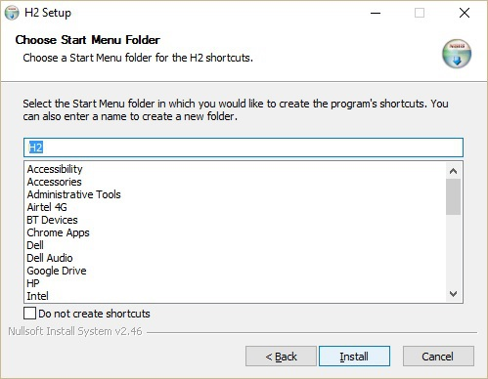

In the above screenshot, click on the **Install** button to start the installation process. After installation, we get the following screenshot:

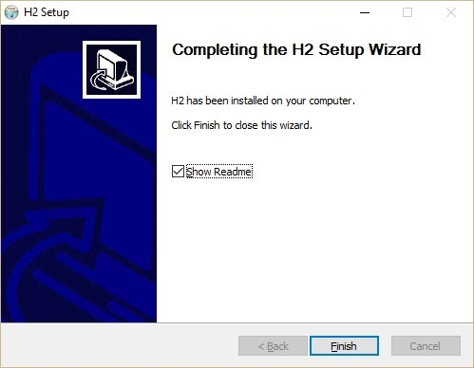

Click on the **Finish** button to complete the installation process.

### **Step 3: Verify H2 Database Installation**

After installation, l verify the database installation in the system. Click **Windows → type H2 Console →** Click the **H2 console icon** or type the below command in your browser's URL:

<http://localhost:8082/login.jsp>

* At the time of connecting, the H2 database will ask for database registration, as shown in the following screenshot.

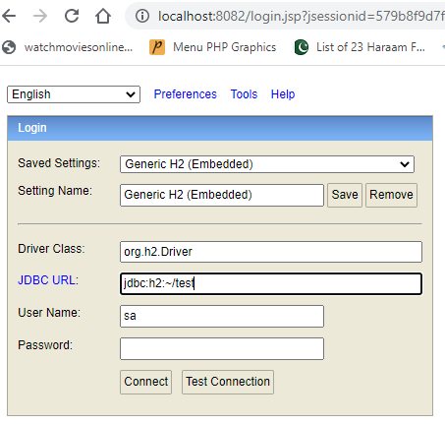

*Note: The H2-in-memory data can be accessed and managed by Web-Based GUI, which we can be accessed by localhost:8020 or IP-ADDRESS:8020.*

Fill the details in the above dialog box as shown below:

JDBC URL:  **jdbc:h2:~/test**

User Name:  **sa**

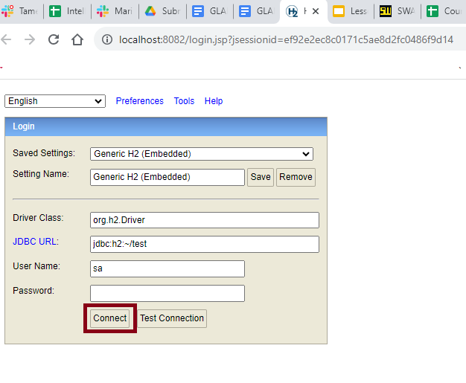

Click on the **Connect** button as shown below in the screenshot:

The welcome page for the database pops up as shown in the following screenshot:

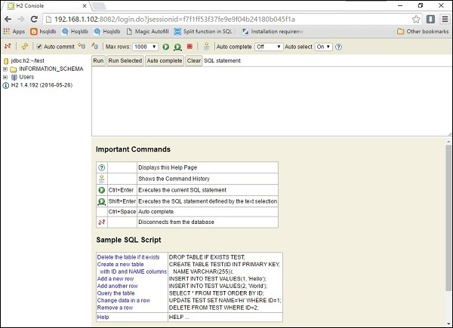

The H2 Console allows you to query and change data visually.

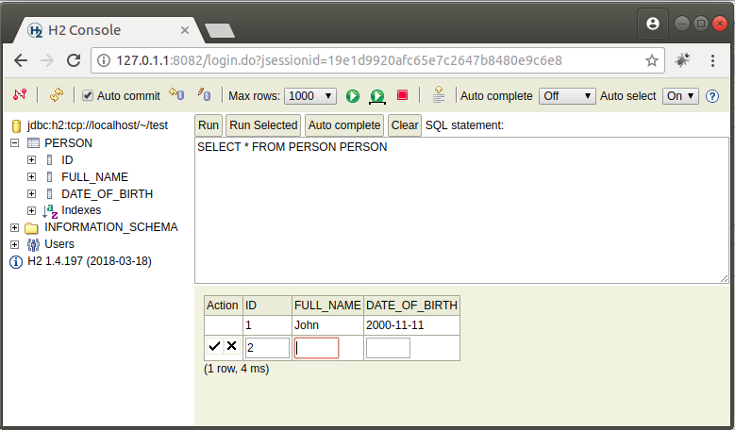

**Canvas Submission Instructions:**

Include the following deliverables in your submission -

* + Take a screenshot of the H2 Database and submit your screenshot using the Start Assignment button in the top-right corner of the Assignment page in Canvas.

## 